**FIT – Barcelona, Madrid, Sevilla**

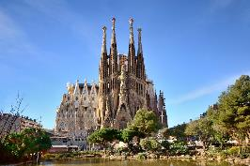 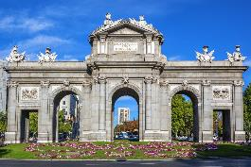 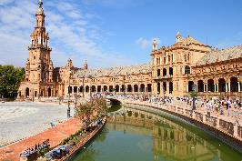

**day 1 Barcelona**

**private transfer** from Barcelona airport to the hotel in Barcelona.

**leisure time** to enjoy the city.

overnight at hotel in Barcelona.

**day 2 Barcelona**

breakfast at the hotel.

**Barcelona sightseeing** based on a hop on- hop off bus.

*the tour will highlight all the things to do in the city so that you can hop on and off at your convenience at more than 44 stops. the key sights are included on the tour including the gothic quarter which is the centre of the old city of Barcelona. a great number of buildings are world heritage sites. especially remarkable is the work of architect Antoni Gaudi, which can be seen throughout the city****; the Sagrada Familia cathedral, Casa Batlló, Casa Mila and Park Güell.***

overnight at hotel in Barcelona.

**day 3 Barcelona - Madrid**

breakfast at the hotel.

**private transfer** to Barcelona train station to take the train to Madrid.

**private transfer** to the hotel & check in.

**Madrid sightseeing** based on a hop on- hop off bus.

*hop on the bus, put on your earphones, listen to the recorded commentaries and enjoy the streets, monuments and places of interest that you pass by. in addition, you will be able to hop off the bus wherever you want.*

overnight at hotel in Madrid.

**day 4 Madrid**

breakfast at the hotel.

**Toledo excursion** on regular basis.

*Toledo is one of the Spanish cities with the greatest wealth of monuments. known as the “city of the three cultures”, because Christians, Arabs and Jews lived together there for centuries, behind its walls Toledo preserves an artistic and*

*cultural legacy in the form of churches, palaces, fortresses, mosques and synagogues. this great diversity of artistic styles makes the old quarter of the capital of La Mancha a real open-air museum.*

overnight at hotel in Madrid.

**day 5 Madrid**

breakfast at the hotel.

free **day at leisure** for shopping and sightseeing.

overnight at hotel in Madrid.

**day 6 Madrid - Sevilla**

breakfast at the hotel.  
**private transfer** to Madrid train station to take the train to Sevilla.

**private transfer** from Sevilla train station to hotel.

**Sevilla sightseeing** based on a hop on hop off bus.

*as political capital of Andalucía, Sevilla houses the government and parliament of this autonomous region. the legend says Sevilla was founded by Hercules. you will see the Plaza de España and adjoining Maria Luisa Park, which are among the most pleasant and impressive public spaces in Spain. another impressive monument you will see is the Gothic Cathedral, which is the burial site of Christopher Columbus.*

overnight at hotel in Sevilla.

**day 7 Sevilla**

breakfast at the hotel.

full day **excursion to visit the Alhambra in Granada**, regular basis.

*Granada is situated at the foothills of the Sierra Nevada mountain range. it was once the capital of the Moorish kingdom, which has left Granada with the most important Moorish legacy in spain; the Alhambra, one of the most brilliant jewels of universal architecture.*

overnight at hotel in Sevilla.

**day 8 Sevilla**

breakfast at the hotel.

**departure transfer** to Sevilla airport.

**end of services**

**prices**

|  |  |  |  |
| --- | --- | --- | --- |
| **price per person & package** | **Nov - Mar** | **Apr - Oct** | **Jul - Aug** |
| **standard class** | **670 €** | **775 €** | **715 €** |
| child standard price (up to 12 yrs) | **285 €** | **296 €** | **285 €** |
| single supplement | **235 €** | **285 €** | **255 €** |
| **first class** | **750 €** | **855 €** | **765 €** |
| child first price (up to 11 yrs) | **225 €** | **240 €** | **240 €** |
| single supplement | **285 €** | **380 €** | **300 €** |
| **superior class** | **945 €** | **1.155 €** | **988 €** |
| child superior price (up to 11 yrs) | **250 €** | **275 €** | **250 €** |
| single supplement | **435 €** | **610 €** | **469 €** |

* prices per person based on double room & bb basis. taxes included. prices valid for minimum 2 traveling pax. prices for children sharing room with 2 adults.

* prices subject to availability and possible fluctuations in any of the requested services at the time of final booking.

**validity**: **until October 2020.**

inclusions:

|  |  |  |  |  |
| --- | --- | --- | --- | --- |
| **city & nights** | **transfers** | **sightseeing** | **meals** | **24h.  phone assistance** |
| **2n Barcelona** | private  apt-htl-apt | hop on hop off bus | breakfast |
| **3n Madrid** | private apt-hotel-station | hop on hop off bus  half day Toledo excursion | breakfast |
| **2n Sevilla** | transfer  station-htl-apt | hop on hop off bus  full day Granada excursion | breakfast |

prices do not include:

* regional tourist tax.
* tips and guests’ extras.
* any other service not mentioned on the programme/ itinerary described.
* train tickets, please find supplements below:
  + *AVE high speed train Barcelona – Madrid:   
    per person on tourist class:* ***from******107,70 €*** *(+ 4% handling fee)*
  + *AVE high speed train Madrid – Sevilla:  
    per person on tourist class:* ***from 76,50 €*** *(+ 4% handling fee)*
* **transportation to sightseeing meeting points is not included, we recommend the use of public transportation or taxi.**

**optional supplements**:

|  |  |  |
| --- | --- | --- |
| C:\Users\marketing2\Downloads\camp-nou.jpg  **football tickets**  **on request** (prices average 48-250 €) | C:\Users\marketing2\Downloads\Camp02.jpg  **Barça – Camp Nou stadium tour**  adult: 26 € child (6-13): 21 €  *\*with time and date given* | C:\Users\marketing2\AppData\Local\Microsoft\Windows\INetCache\Content.Word\madrid-entrada-santiago-bernabeu.jpg  **Real Madrid stadium tour**  adults: 25 € children: 18 € |
| C:\Users\marketing2\AppData\Local\Microsoft\Windows\INetCache\Content.Word\Flamenco-Madrid-400x300.jpg  **flamenco show & drink**  from: 28€ | C:\Users\marketing2\Downloads\cordoba.jpg  **full day Córdoba from Sevilla**  105 € | C:\Users\marketing2\Downloads\crucero-por-el-guadalquivir-1000-1000x580.jpg  **Guadalquivir cruise** 1h duration  adults: 16€ children (0-12): free |

* prices per person.

**itinerary & number of nights**

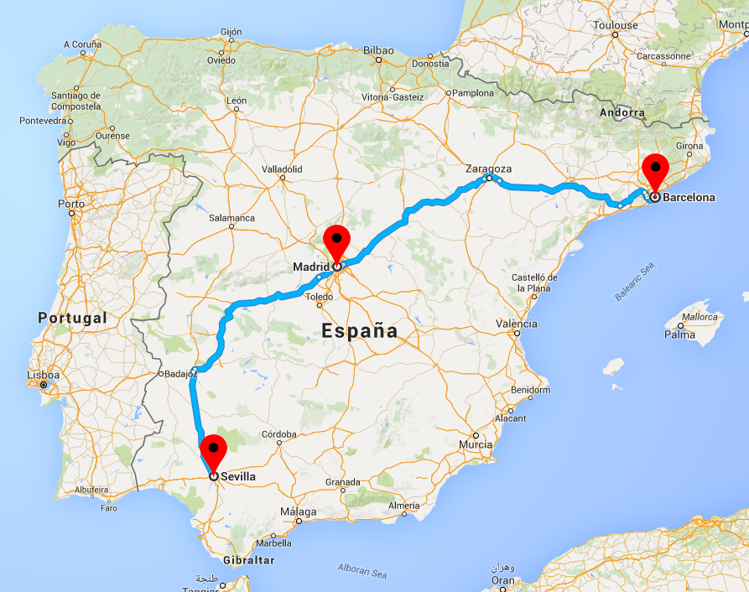

**2n**

**Barcelona**

**3n**

**Madrid**

**2n**

**Sevilla**